**Supplementary Materials**

**Virologica Sinica**

**Structural and functional insights into the 2'-O-methyltransferase of SARS-CoV-2**

Jikai Deng a, 1, Feiyu Gong a, 1, Yingjian Li a, Xue Tan a, Xuemei Liu a, Shimin Yang a, Xianying Chen a, Hongyun Wang a, Qianyun Liu a, Chao Shen a, Li Zhou a, b, Yu Chen a, b, *

aState Key Laboratory of Virology, RNA Institute, College of Life Sciences and Frontier Science Center for Immunology and Metabolism, Wuhan University, Wuhan, 430072, China.

b Animal Bio-Safety Level III Laboratory/Institute for Vaccine Research, Wuhan University School of Medicine, Wuhan, 430071, China.

1 Jikai Deng and Feiyu Gong contributed equally to this work.

*Corresponding author:

Email address: chenyu@whu.edu.cn (Y. Chen)

ORCID: 0000-0004-0611-3954

**Supplementary data**

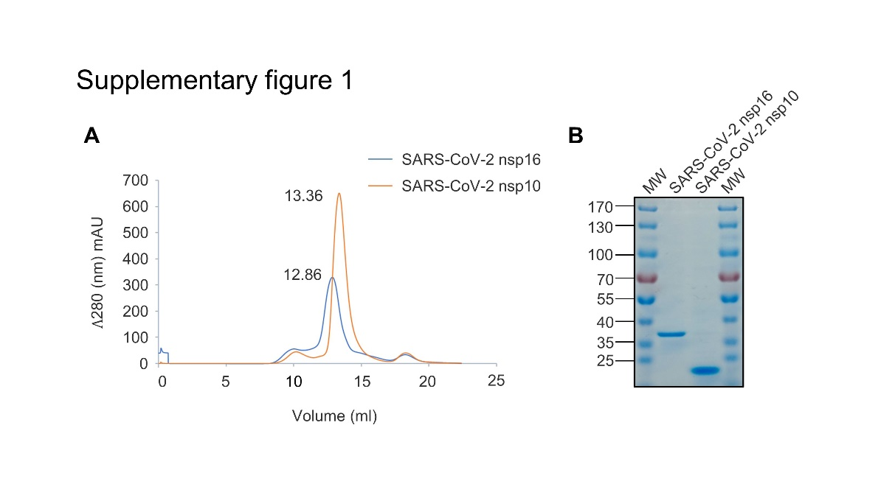

**Supplementary Fig. S1.** Recombinant protein expression and purification. **A** The elution chromatogram (λ280, mAU) of SARS-CoV-2 nsp16 (blue) or nsp10 (orange) showed a main peak. The corresponding elution column volumes of nsp16 and nsp10 were 12.86 mL and 13.36 mL, respectively. **B** The purified proteins were separated using SDS-PAGE and stained with Coomassie blue. MW, molecular mass markers.

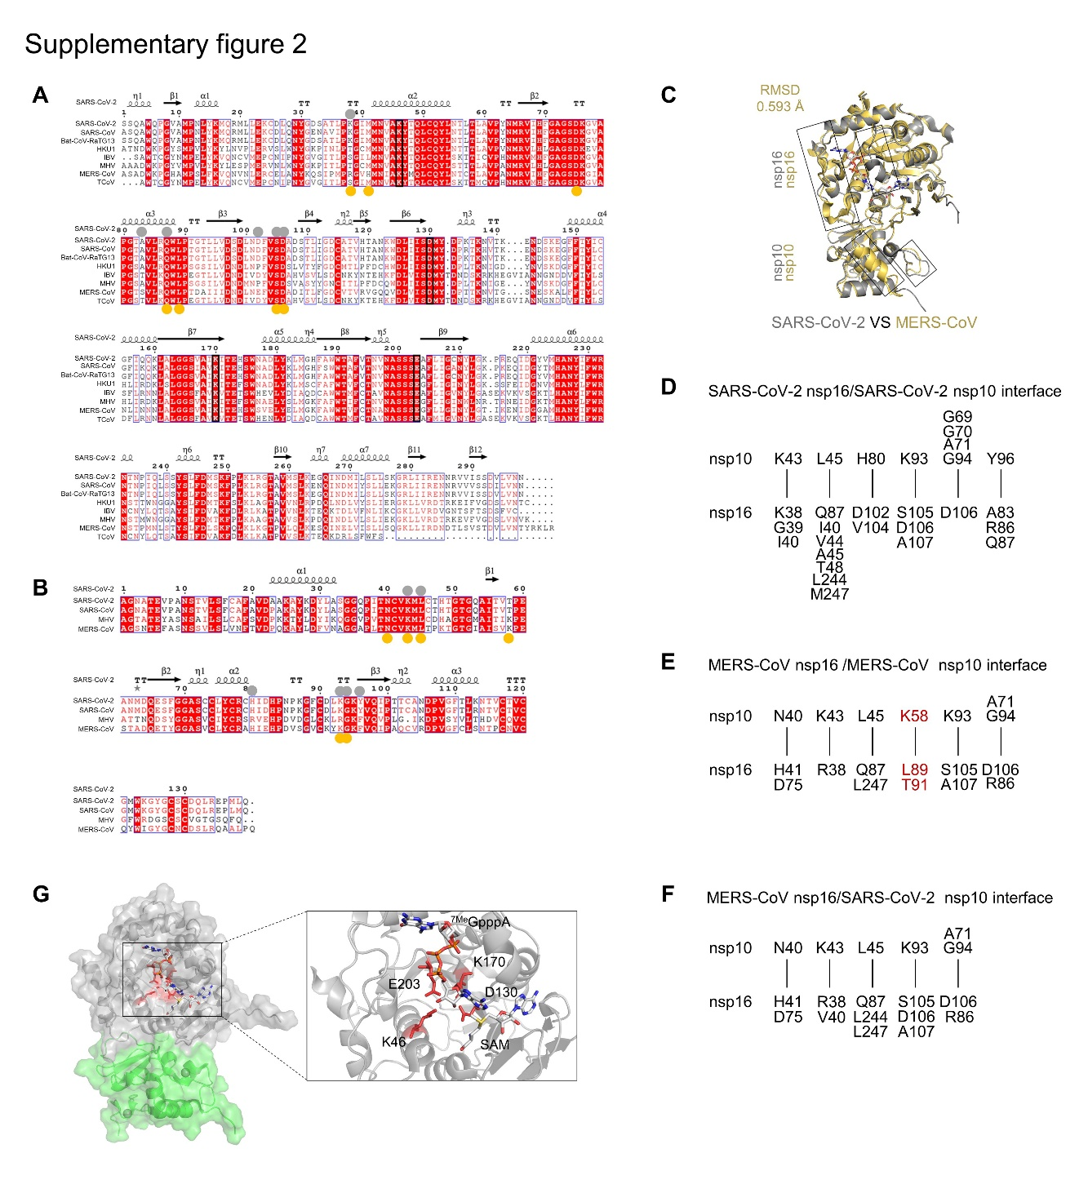**Supplementary Fig. S2.** Multiple sequence alignment and structural analysis. **A, B** Multiple-sequence alignment of nsp16 amino acid sequences (**A**) and nsp10 amino acid sequences (**B**) across diverse coronaviruses. The K-D-K-E catalytic tetrad was highlighted in a black box. The nsp16/nsp10 interface of SARS-CoV-2 was highlighted in a gray circle, while that of MERS-CoV was highlighted in a yellow circle. **C** Superimposition of the nsp16/nsp10 structure of SARS-CoV-2 (PDB 6WKS, cartoon, gray) onto those of MERS-CoV (PDB 5YN5, cartoon, yellow). **D**–**F**The schematic summary of nsp16 and nsp10 residues of SARS-CoV-2 (**D**), MERS-CoV (**E**), and MERS-CoV/SARS-CoV-2 (**F**), directly interacting within a 3.5 Å range, was presented. Distinct residues were denoted in red. **G** The overall structure of nsp16/nsp10 complex was shown as surface and cartoon with 40% transparency. Lys-46, Asp-130, Lys-170 and Glu-203 were both shown as sticks and colored in red. SAM and 7MeGpppA were depicted as stick colored by atoms (C: white, H: white, N: blue, O: red, S: yellow).